RIAK – KEYVALUE DATABASE

# THE PUTINSTRUCTION:

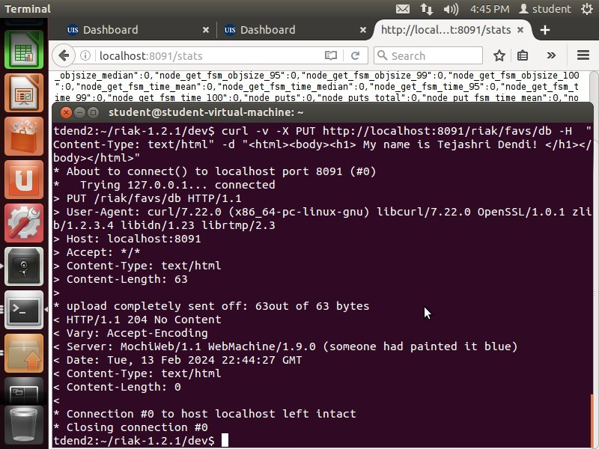

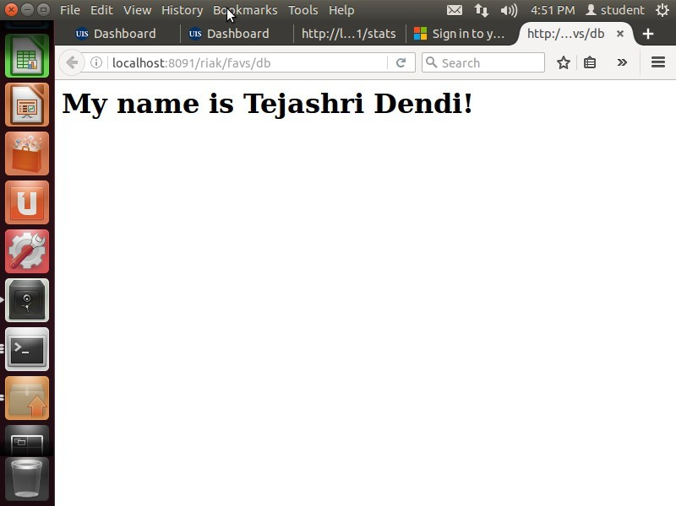TheresultofPUTinstruction:

# RETURNINGTHESETRESULTS:

Returnedfallout4game-

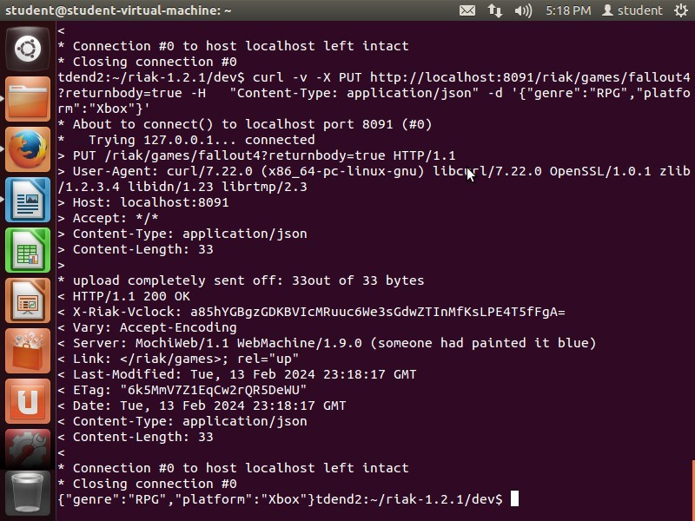

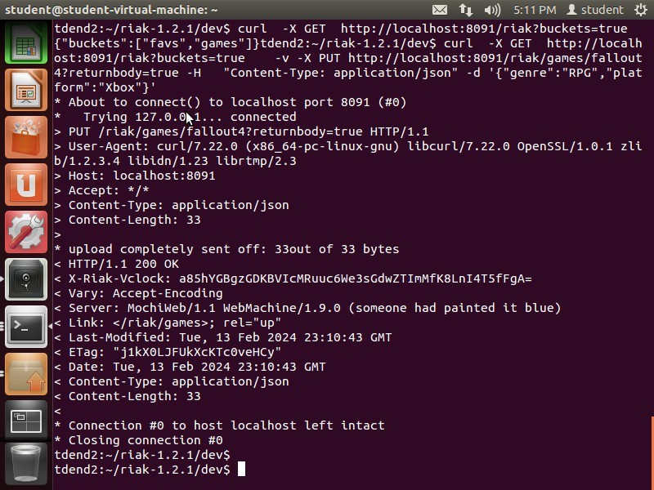Returnedset-game results:

Return/listthebucketscreatedsofar:



# LINKWALKING:

Get shelf1:

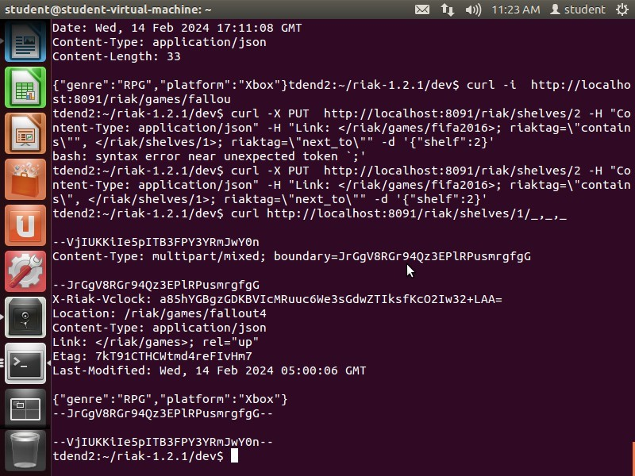

Shelf-2:fifa2016-

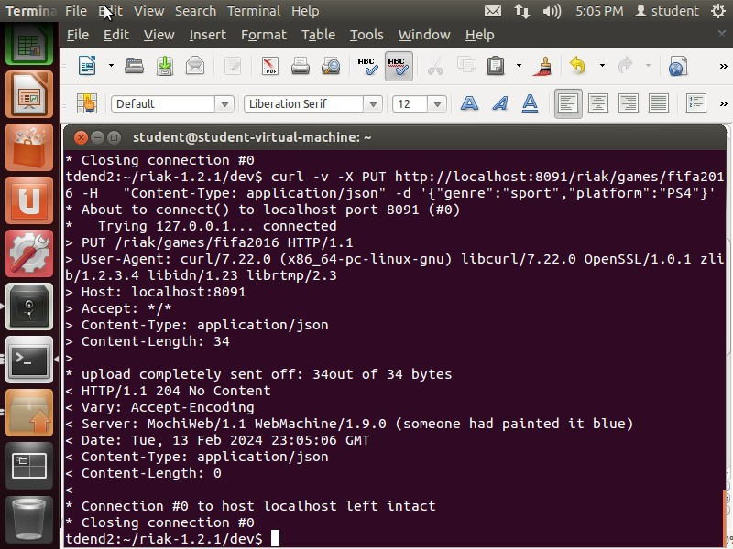

Shelf2isconnectedtoshelf1:

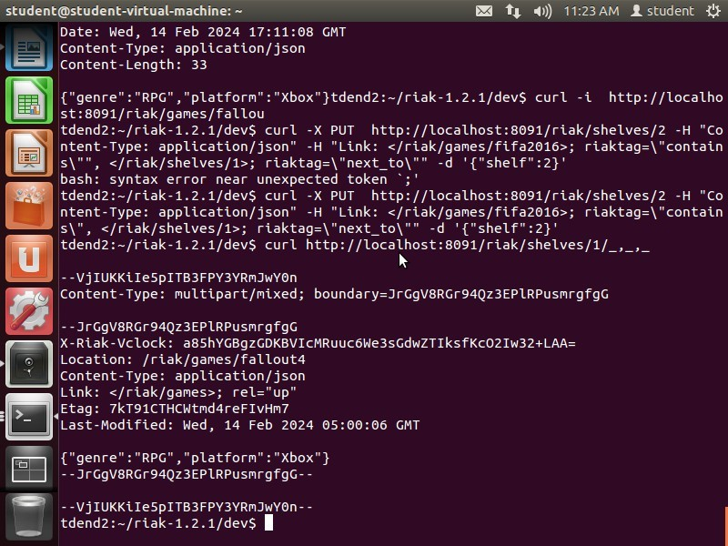

Linkspec:

Populatetag criteria

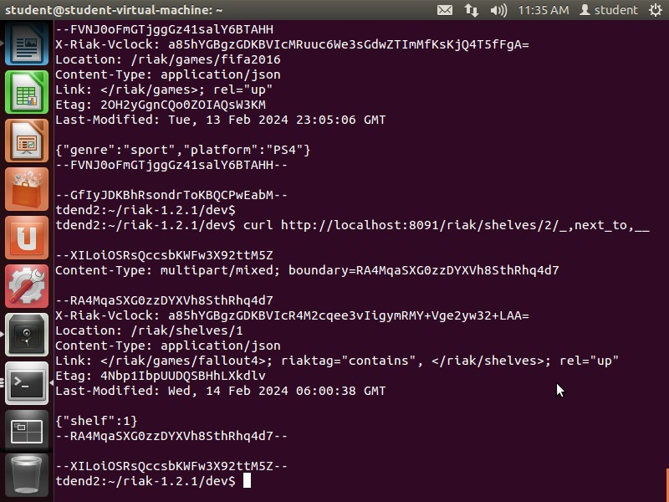

keep-

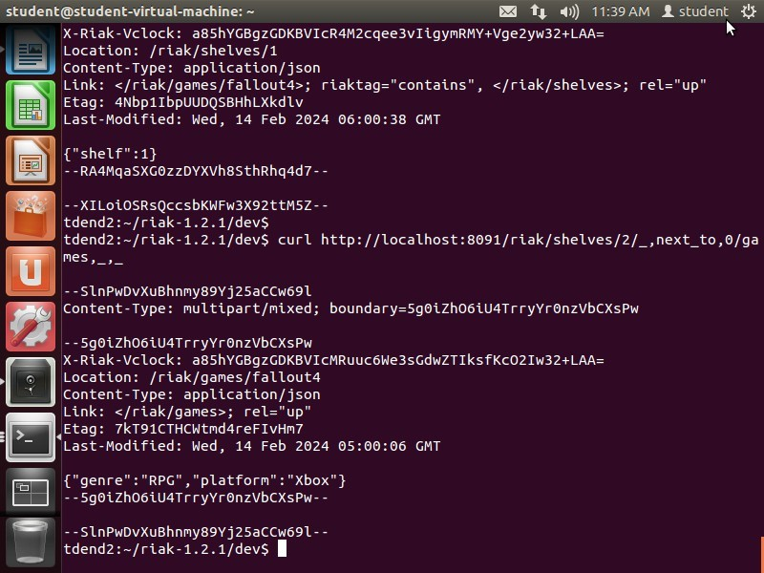

# AUTO-GENERATIONOFKEY:

Autogeneratedakeytogamesbucketif unspecified:

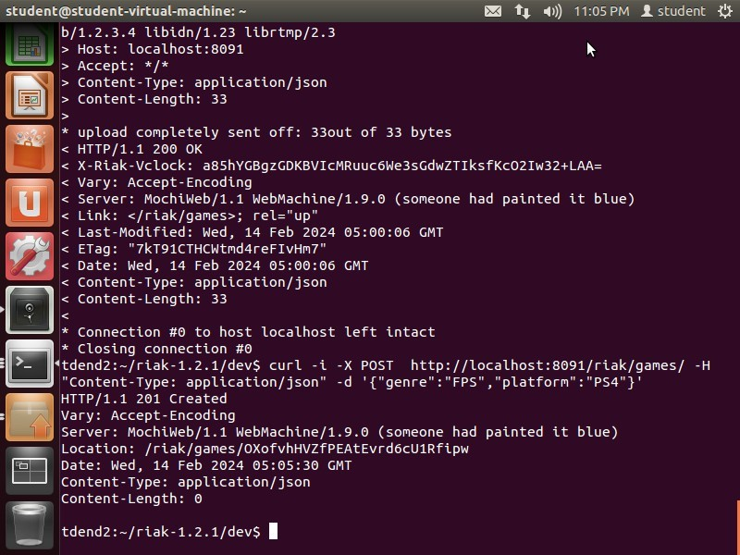



Theaboveoneillustrateshowtoreturnthebodyofbucketcreatedwhichhelpsinknowingthecontent created. (continuation of PUT)

------------------------------THE-------END-------OF-------ASSIGNMENt#1-----------------------------------

# ASSIGNMENT#2

ADD6MOVIES-

1. Thebelowscreenshotof**Psycho**movieaddedtomovies– bucket:

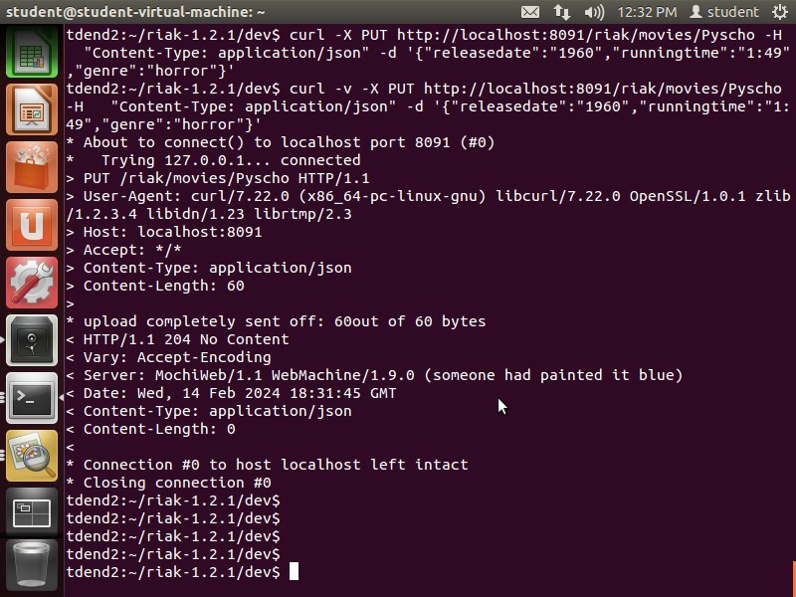

1. Thebelowoneisof**Accepted**movie:

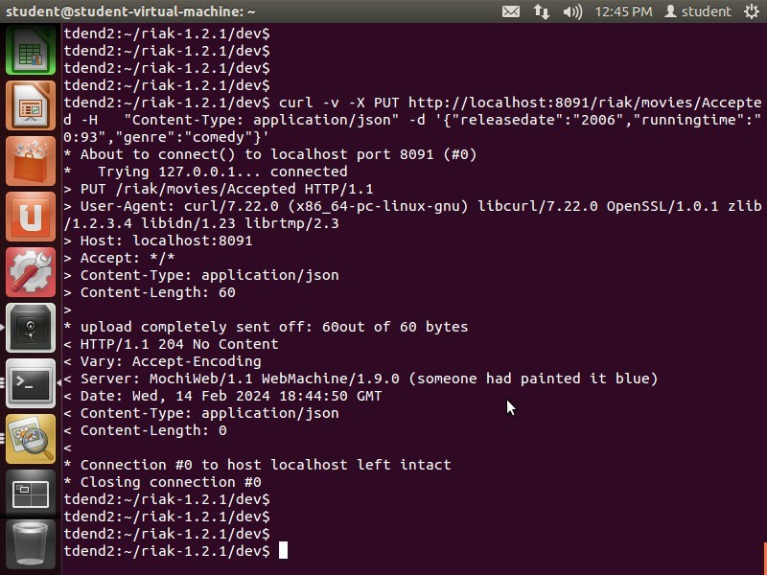

|  |
| --- |
|  |
|  |
|  |
|  |
| tdend2:.-/riak1.2..1/dev\cunT v X http:/TocaThost:8Ä9J/nTak/novTes/Pyscho  ’6ont entType:appTTcatTon/json’ d ’neTeasedate":’196a",’nunnTngtTne’:":  49 |
| TpyTng127..Ö..0..1 connected |
|  |
|  |
|  |

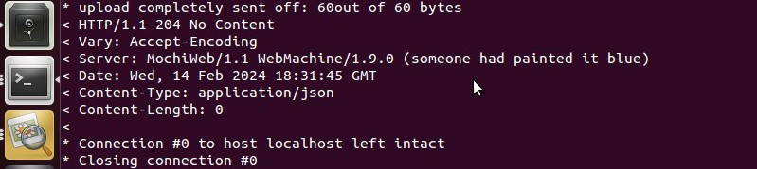

*m*

tdend2: -/r iaktdend2:.-/riaktdend2:-/skak tdend2: -/skak tdend2: -/r iak

..2.1/deva

1.2..1/deva

1..2.1/deva

..2..1/deva

..2.1/deva

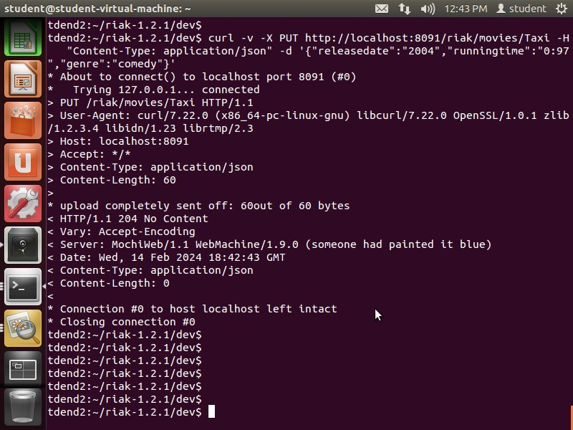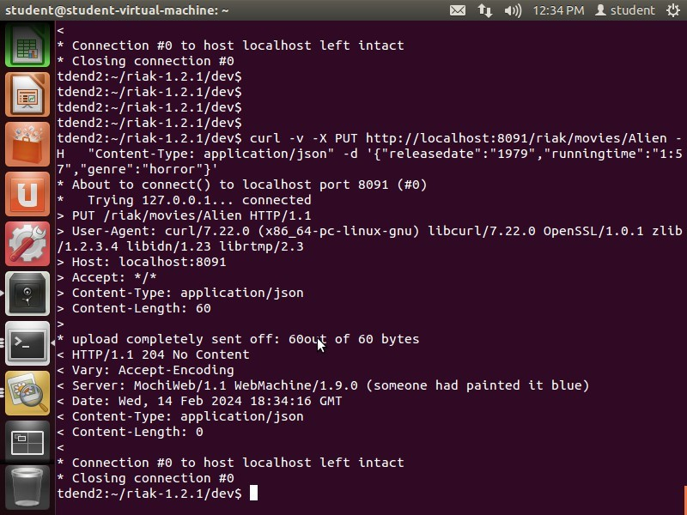

1. The**taxi**and4)**alien**moviesaddedtobucket:areas follows:

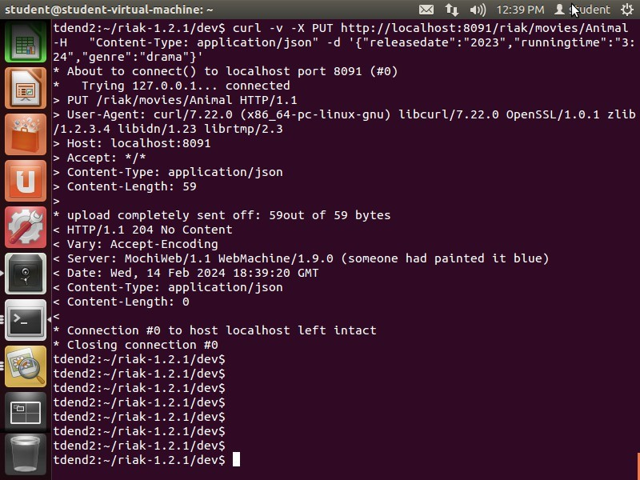

1. Screenshotof**Animal**movieaddedtomoviesbucket.

'**Accepted**'movieisinmoviesbucket:



# ALIENMOVIE:



1. **Saltburn**movieaddedtomoviesbucket:

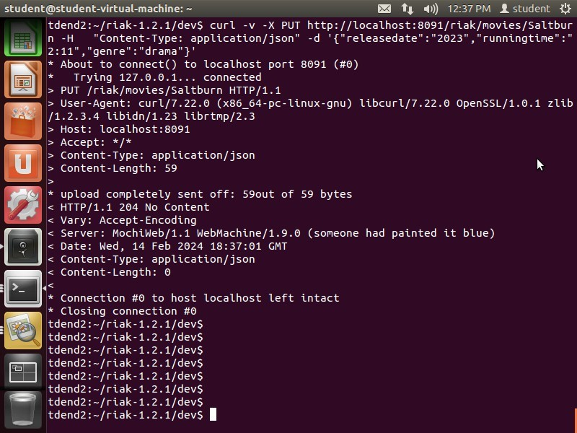

# DELETEAMOVIERECORD:

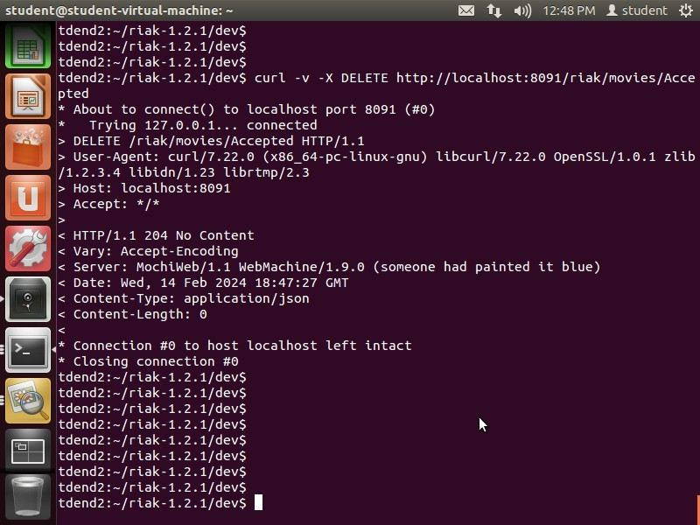

Createbranchesandlinktomovies: East branch

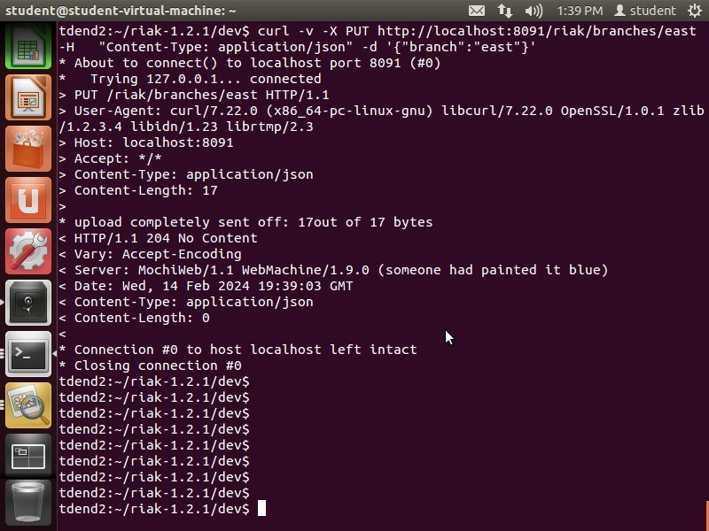

Southbranch:

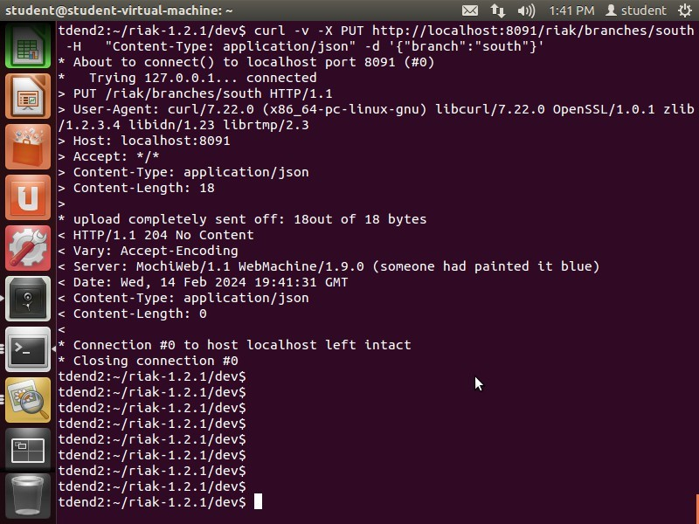

West-branch:

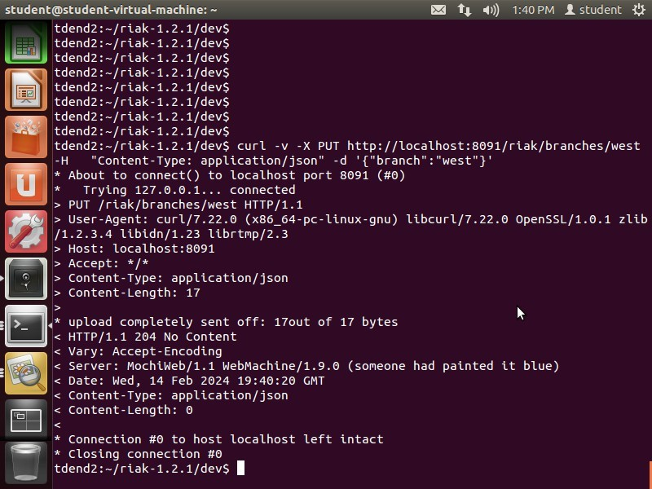

# CREATEBRANCHES:

Eastbranch:

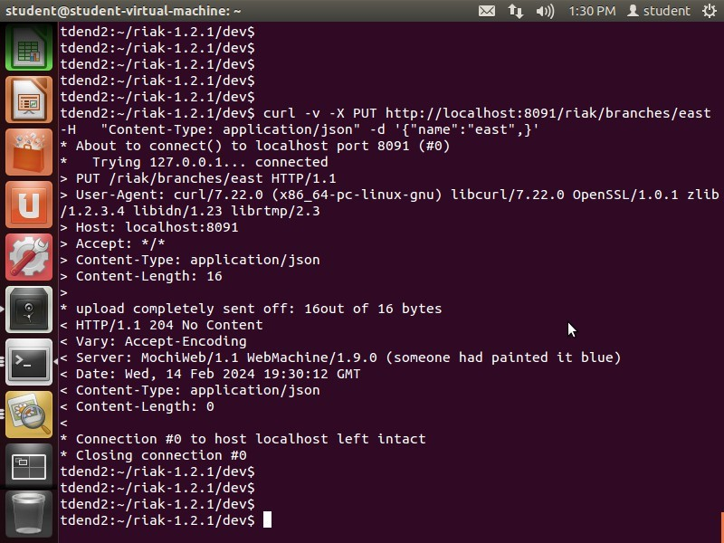

Southbranch:



Westbranch:

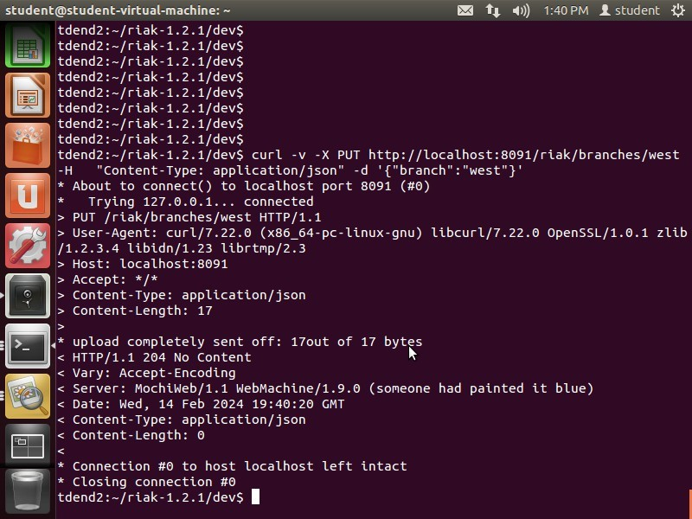

# LINKBRANCHESTOMOVIES:

PsychomovieisaddedtoBranch-East:

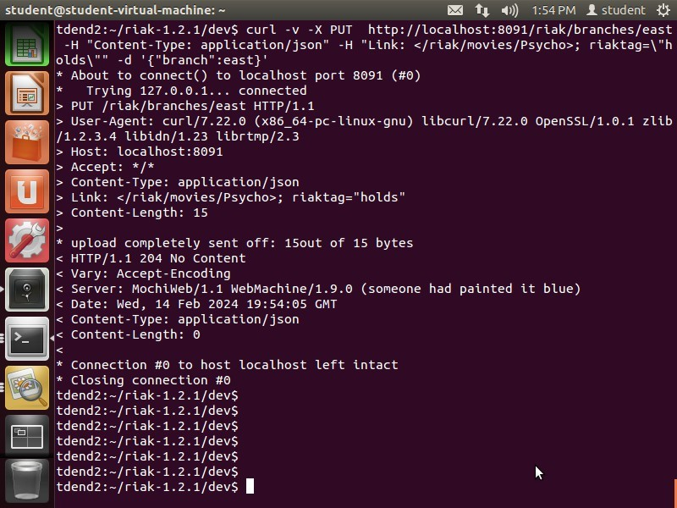

Saltburnmovieisaddedtothebranch-south:

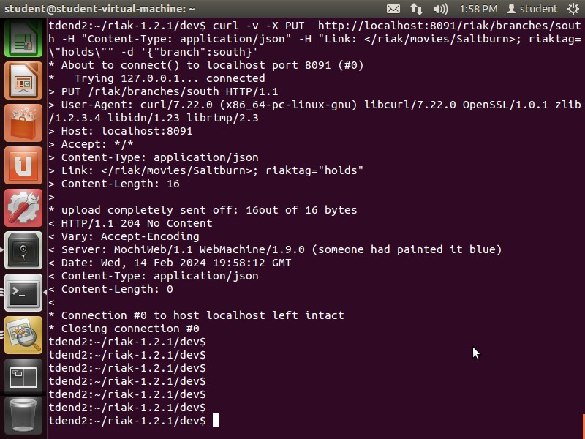

AlienismadeavailableattheEastbranch:

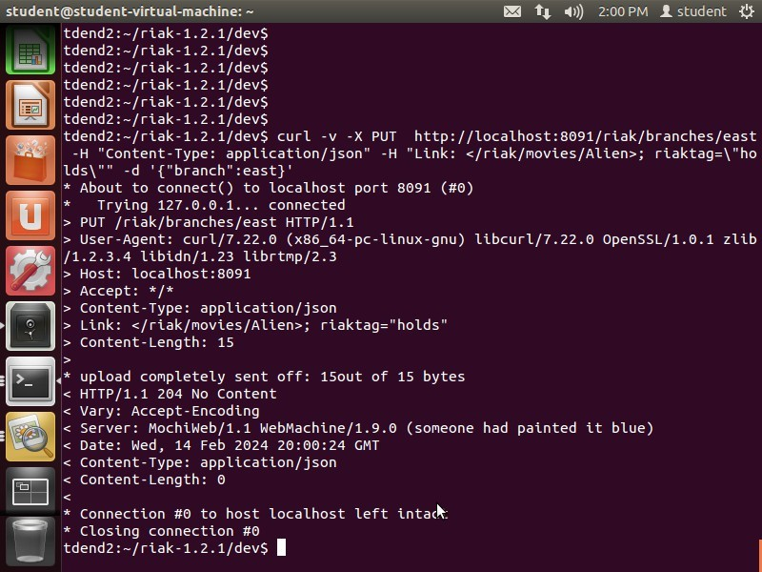

AnimalmovieismadeavailableattheSouth branch:

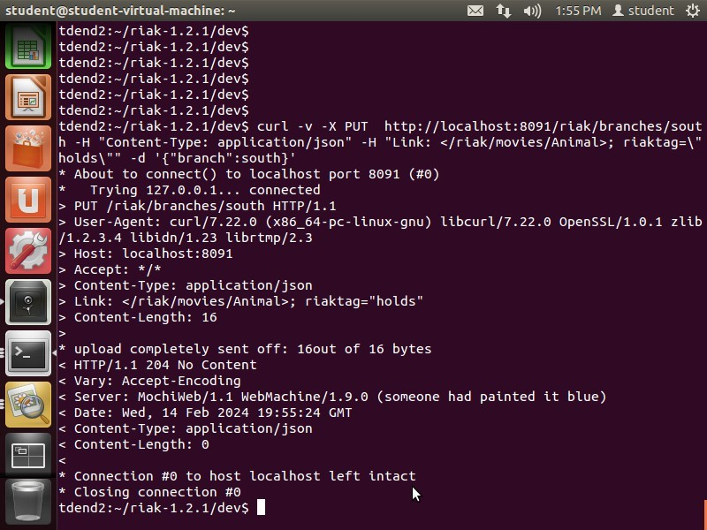

Taximovieisconnectedtothebranches-eastandwest:

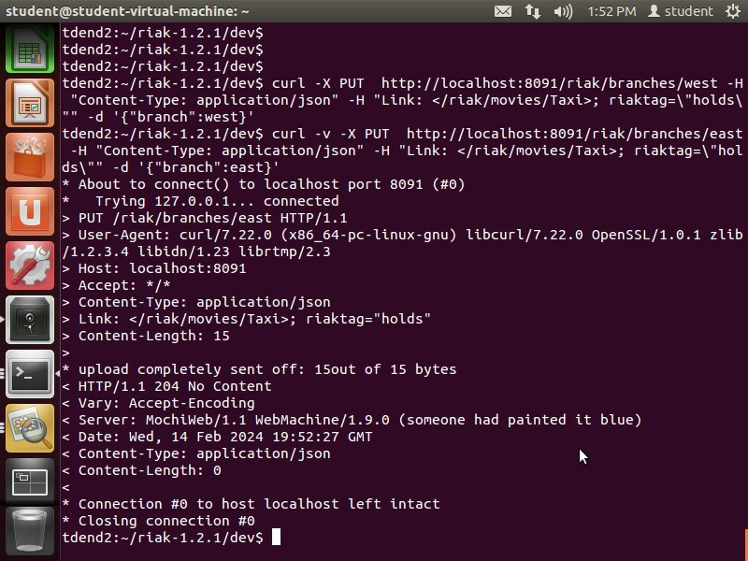

# DOWNLOADAPICTUREANDLINKITTO MOVIE:

Taxipictureofmovietaxiisdownloadedandlinkedtotaxiwhichisinmoviesbucketusingatagso thatit directs to the movie whenwe click on it.

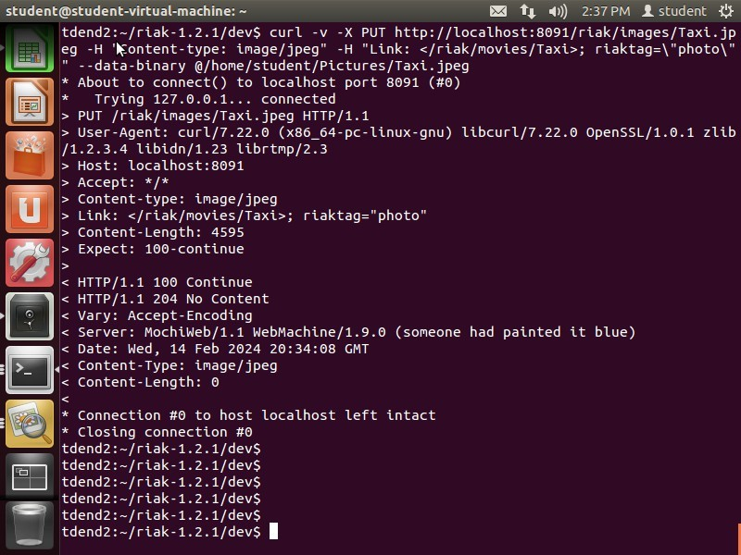



Listofall buckets:

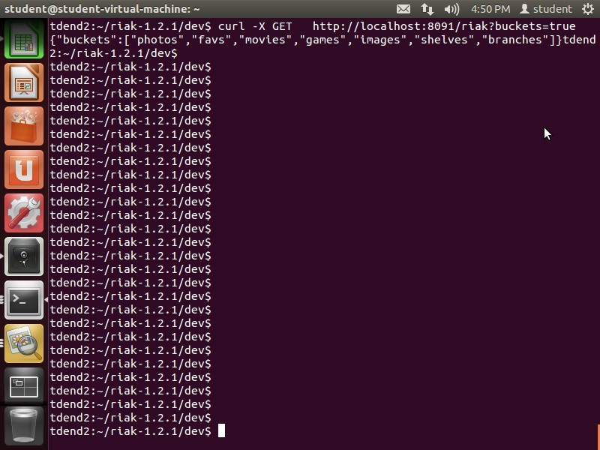

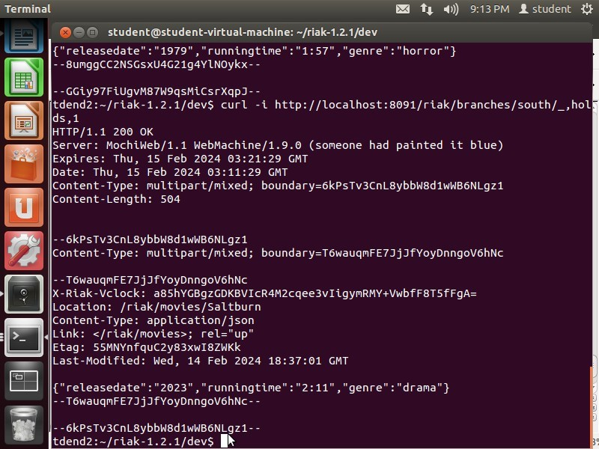List all movies linked to each branch: SaltburnisavailableinSouthbranch:

Taximovieisavailableinwestbranch:

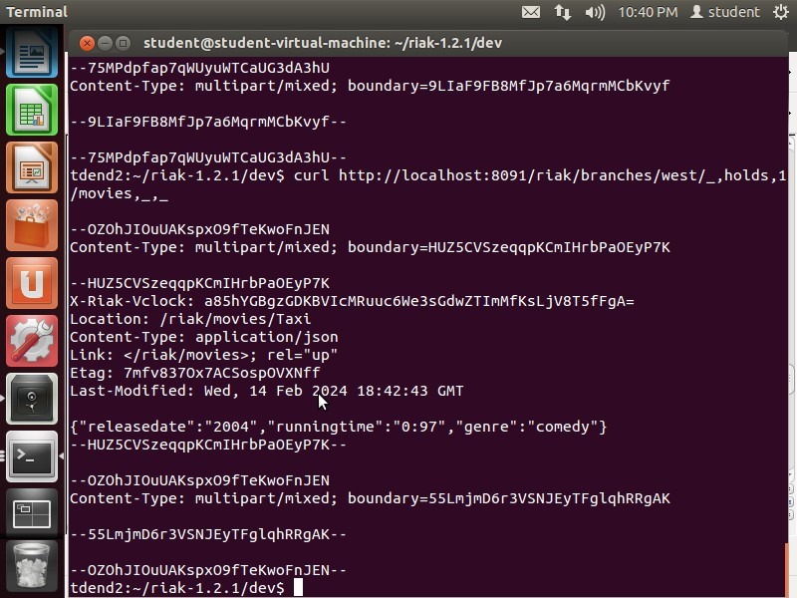

AlienmovieateastBranch: With keep:

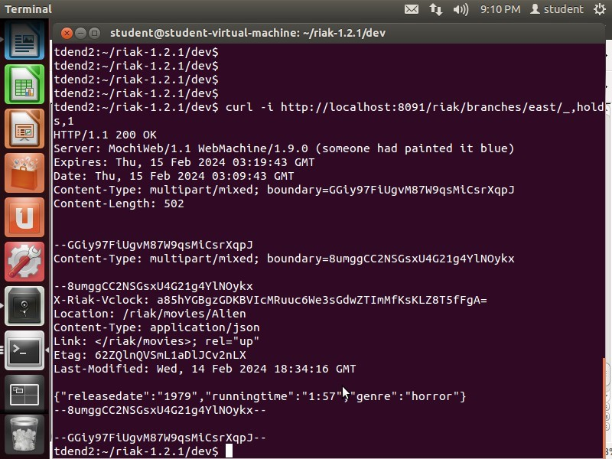

AlienmovieateastwithoutKeep:

